Project:

* Northwind Traders is a company that imports and exports specialty foods from around the world.
* They need a way to keep records of their business and have enlisted your help in creating a technical solution for them.
* Requirements are provided in the form of an Entity-Relationship Diagram.

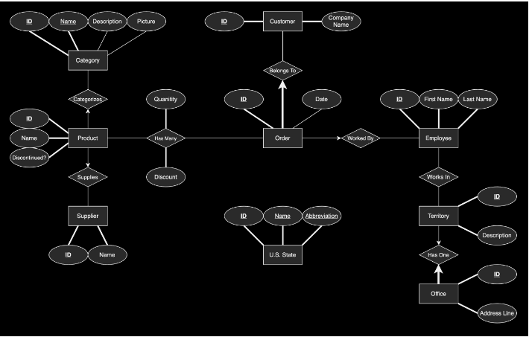ER Diagram:

Relationship table:



